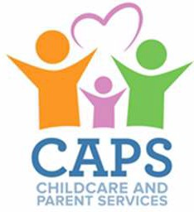
CAPS Referral for Georgia’s Pre-K Program
School Year to

Families with children enrolled in a lottery-funded Georgia's Pre-K classroom who meet income and activity requirements may receive assistance with the cost of extended day services through the Childcare and Parent Services (CAPS) program. These arrangements should be made between the family and the CAPS program.
- Families requesting assistance with child care costs should apply online and upload this form through Georgia Gateway (www.Gateway.ga.gov).

- Families who already receive CAPS should report Pre-K as a change through Georgia Gateway (www.Gateway.ga.gov) or by contacting your Family Support Consultant at 1-833-4GA-CAPS (833-442-2277).

Family Information

Parental Authority Name:

Do you currently receive CAPS? Yes No

If Yes, CAPS ID or Case ID:

Phone Number: Email Address:

Provider Information

Georgia Pre-K Site Name:

Site Phone Number:

Site Address:

My child is enrolled in a Georgia's Pre-K classroom. Yes No

Child Care Provider Name (if not Pre-K Site):

Provider Phone Number:

Provider Address:

Georgia’s Pre-K Program Operating Guidelines Appendix K – revised 6/2022

