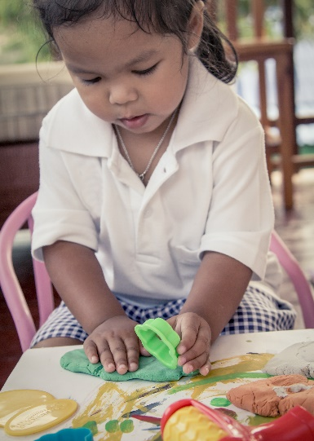
Looking for Childcare?
We are open and ready to enroll!

Dear Families,
Our program [insert name] is currently open and serving families during the COVID-19 crisis. If you are in need of child care, please contact us at [insert phone number and/or email address] to enroll your child. Our program is [insert description of your program- are you quality rated, do you accept CAPS, what age children do you serve, etc]. We look forward to serving you and your family.
Respectfully,
[Director/Owner name]
[Program Name and Address]

