COLYAR CONSULTING GROUP, INC.

Web Based Child Nutrition Programs – SFSP

SFSP Claims - Site Level Claiming
User Guide

Summer Food Service Program
For Sponsors

May 2007

Table of Contents

Introduction 1
Web Site Benefits and Features 1
Sponsor User Manual 1
Getting Started 2
Accessing the Web Site 2
Logging On 2
System Navigation 3
Quick Navigation Buttons 4
Main Menu 4
Error Processing 5
Input Edits 5
Business Rule Edits 5
How To: Resolve Error Messages 6
Claims 7
Sponsor Claim Menu 7
Site Level Claim 8
Claim Upload 16
Generate the file 16
Upload the file 17
Notes 19

Introduction
1
Welcome to the CNP 2000 Summer Food Service Program (SFSP) on the Bright from the Start: Georgia Department of Early Care and Learning web site.

Web Site Benefits and Features
The CNP2000 system is a menu-driven, graphical user-interface with comprehensive maintenance utilities allowing online submission and approval of documents and claims via the Internet by State Agency personnel and Sponsor users. Other key system features are:
- Through a single interface, information regarding sponsors, applications, claims, reports, and advances is managed.
- A single database works behind the scene to combine core information, which can be utilized across the child nutrition programs.
- Partially completed documentation can be saved on-line, allowing the user to complete the process at a later time.
- User access to the programs is via login ID and password. User access to functionality within the system is assigned by Security Groupings, with all user access administered by State Agency personnel.

Sponsor User Manual
This user manual is intended for use by the SFSP Sponsors. It is designed to provide a general understanding of how to use the CNP 2000 web site to utilize the Georgia SFSP program efficiently. To achieve this objective the manual will provide:
- A general explanation of each feature available
- Screen examples of web site pages and forms
- Step – by – step instructions for utilizing the web site features
- Tips and Notes highlighted in gray to enhance your understanding of the system

Getting Started
2
Before the user can begin using the CNP 2000 web site the user must have an assigned Username and Password as well as access to the Internet to logon to the web site.

Accessing the Web Site
The CNP 2000 Main page can be accessed by opening your Internet browser and entering the following URL in the Address line: https://www.cnp2000.decal.ga.gov

Tip: You can add this URL to your browser’s FAVORITES list or create a shortcut to the URL on your desktop for quicker access to the site. Refer to your browser or operating system manual or help files for further information

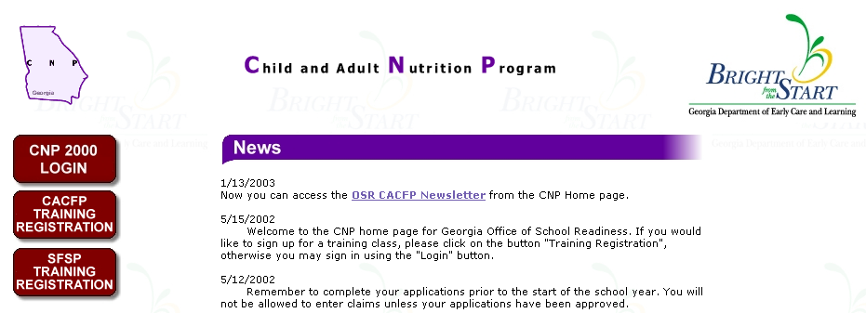
DECAL Main Page

Click on CNP 2000 LOGIN to display the Login page.

Logging On
To logon to CNP 2000, enter your Username and Password then click Login.
Tip: If the user does not have a Username and Password, contact the DECAL Security Administrator.

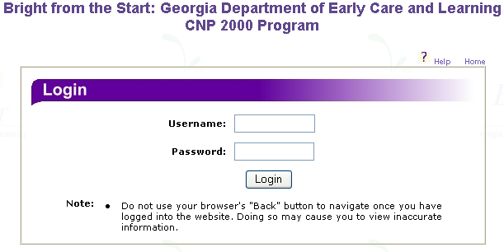
CNP 2000 Login page

System Navigation
Once you login to CNP 2000, the CNP 2000 Summer Food Service Program Home page will display.
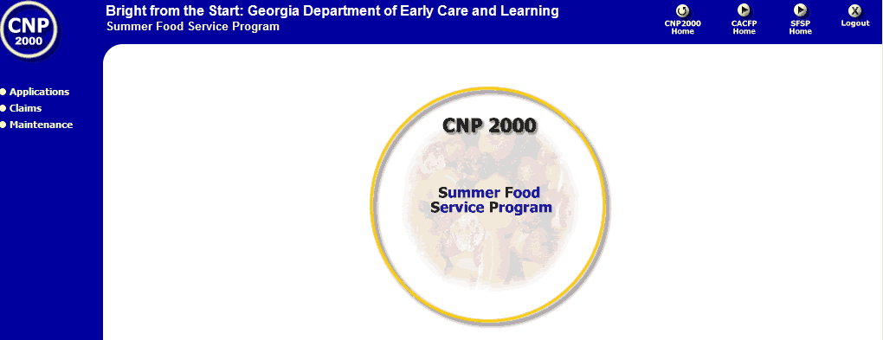
SFSP Home page

From this point forward, all of the pages and forms in the system will be displayed within a blue navigational frame. The two main components of the navigational frame are the Quick Navigation Buttons at the top right corner and the Main Menu on the left-hand side of the screen.
Note: Remember to use the SUBMIT button to save your work before using the Quick Navigation Buttons or Task links to navigate to another page. If the work is not saved or submitted, all input will be lost.

Quick Navigation Buttons

The Quick Navigation buttons are located at the top right corner of the Navigation Frame.

Button | Action
CNP 2000 Home | Returns to the CNP 2000 Home Page
CACFP Home | Displays the Child and Adult Care Food Program Home Page
SFSP Home | Displays the Summer Food Service Program Home Page
Logout | Logs the user off of the system and returns the user to the CNP 2000 Login page.

Main Menu
The Main Menu is a list of expanding submenus located on the left-hand side of the Navigation Frame. Click on a menu (e.g., Applications) to display the list of tasks available under that menu. Click on a task (e.g., Sponsor Application) to work within the task. The submenus listed on the Main Menu and tasks available under each will vary depending upon the users assigned security access/level.

Following is a list of the menus available on the Main Menu together with the tasks available under each. If you are not authorized to access a menu or perform a specific task, it will not be displayed on your Main Menu.

Application
- Report Card - Comparison of data from previous program year to current program year
- Letter of Intent - Allows the user to submit a letter of intent of operation in the SFSP
- Sponsor Application - Allows the user to create, modify or delete information in a sponsor application packet
- Available Forms - Downloadable forms for the SFSP

Claims
- Claim Entry - Allows the user access to the claim form

Maintenance
- Change Password - Allows the user the access to a screen to change the login password.

Error Processing
All information entered in the system is checked to ensure it conforms to data entry guidelines and system rules. The system performs two types of checks on information entered - Input Edits and Business Rule Edits.

Input Edits
The system checks for Input Errors when Submit is clicked. Input Errors are data entry such as entering a 4-digit Zip Code or entering characters in a numeric field. If a form contains input errors, the form redisplays with an Input Error section at the top listing each error in red, with an error code in parentheses. The red error code also displays in front of the field containing the error. Input Errors must be corrected before any data is saved.

Business Rule Edits
Business Rule edits are used to check a form to ensure all required data is entered and to make sure information entered conforms to program rules and regulations, as defined by USDA and DECAL. For example, if you enter meal times, which do not meet the guidelines, you receive a Business Rule error.
The system runs Business Rule edits when a screen is saved on the system. Forms are saved when Submit is clicked. Business Rule errors are displayed in red on the Results screen. The errors also displays the next time the form is submitted. Each error has a Code, a Description and a Type. The code is the number of the Business Rule. The description explains the rule was violated in order to create the error. Errors are listed by type. Errors are listed as either a Critical Error or a Active Error.
- Critical Error – Critical errors must be corrected before an application can be approved.
- Active Error– Warning errors are not crucial to the approval of an application and do not have to be corrected before the application can be approved.

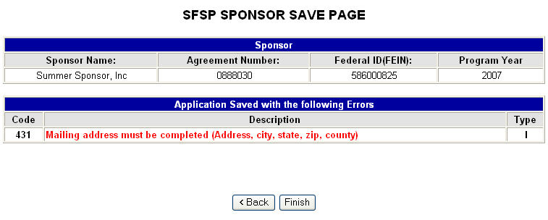

Error Messages

Errors can be corrected immediately or the user can return to the application later to correct the error.

How To: Resolve Error Messages
The How To sections provide step by step instructions for some of the common processes preformed by users.

Follow the steps below to resolve error messages:

- After a screen is saved error messages may appear.

- Read the Error Message to determine what correction is needed.

- Click <Back to return to the screen where the errors exist.

- Make corrections based on the error message description.

- Click Submit to save the changes.

Claims
3
Claims can only be submitted by Sponsors with an approved application. Claims are submitted at the Site level.

Performed By | Task
Sponsor | Submit online Sponsor Claim form
State | Review and approve Claim and Post Payments.

Sponsor Claim Menu
The Sponsor Claim Menu is the starting point for all tasks related to the Sponsor Claim packet. Click on Claims and select Claim. Select a Program year.

Claim Month selection
Click Select in the action column.

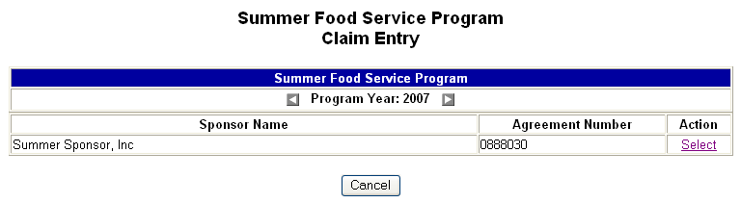
SFSP Claim Entry screen
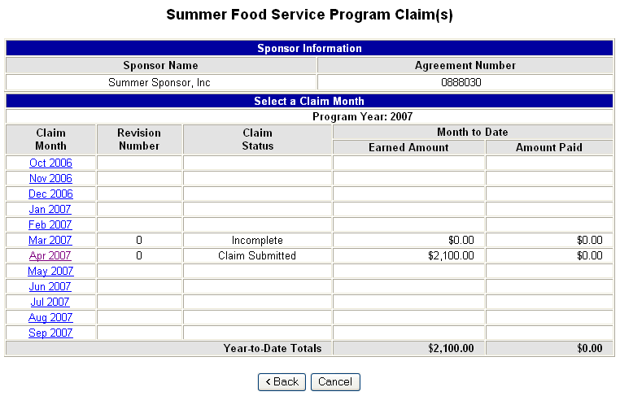
Claim Month selection screen

The Claim Month selection screen lists all claims for the selected Program Year. This screen indicates the revision number, claim status, earned amount and amount paid for each claim. Click on the claim month to add, modify or view the claim.

Site Level Claim

Claims are entered by Site and then rolled up into a single claim. Only Site Claims with no errors will be included in the roll up. Site Claim with errors will not be included in the roll up until the errors are resolved. The roll up procedure is described at the end of the Site Level Claim section.

Click on the Claim Month to view the Month Summary screen.

The SFSP Claim can be entered manually by clicking Add Claim (shown below) or can be uploaded as a file using the Upload Summer Food Claim Information screen. The Upload process will be explained in the following section.

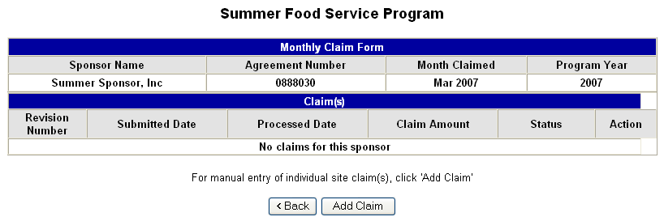
Month Summary screen

Click on Add Claim to add the Site Level Claim.

Site Level Claim
The Institution Cost/Income Total section must be completed before the claim can be processed. At least one site level claim must also be completed.

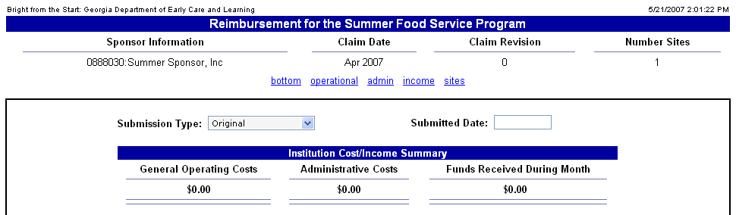
Site Level Claim Menu screen

The user can click on the blue link (bottom, operational, admin, income, sites) to be taken directly to the category to enter the costs. The user can also scroll further down to enter the costs in the sections as shown below.

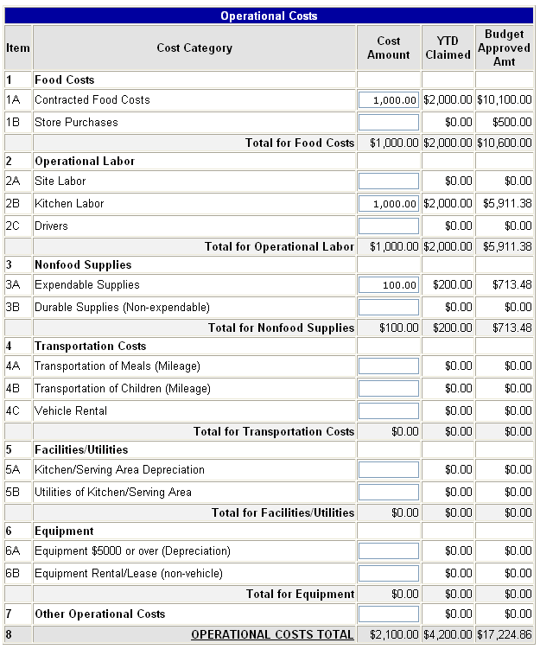
Site Level Claim Menu screen (con’t)

This screen displays the Cost Amount for this claim along with the Year-To-Date amount claimed and the Budget Approved Amount

Note: The YTD Claimed by category cannot exceed the Budget Approved Amount. An error will be displayed if the YTD Claimed amount for any category is greater than the Budget Approved Amount.

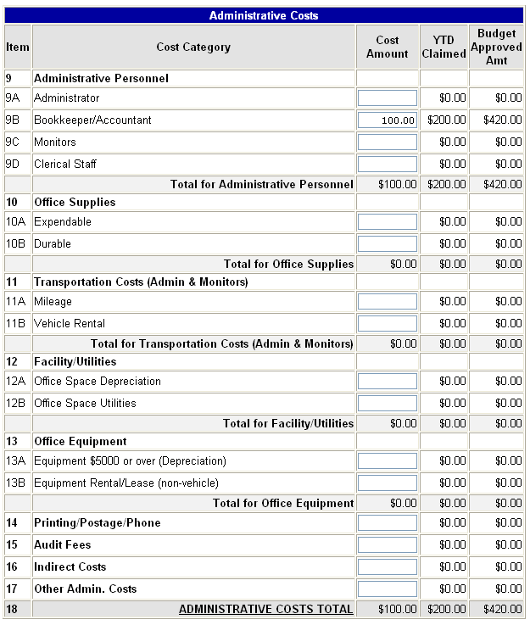

Site Level Claim Menu screen (con’t)

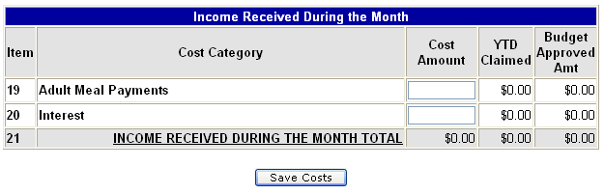
Site Level Claim Menu screen (con’t)

After entering the Operational Costs, Administrative Costs and Income Received during the month, click Save Costs. The system will total the columns and provide a summary of the Institution Cost/Income Totals at the top of the screen. (See the following example).

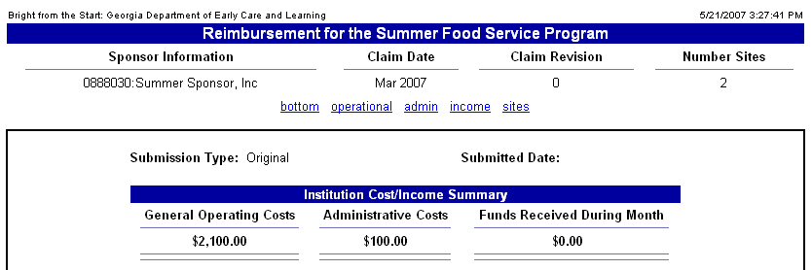
Institution Cost/Income Total screen (con’t)

After entering and saving the costs, the next step is to enter the site claim meal counts by clicking Add in the action column of the site.

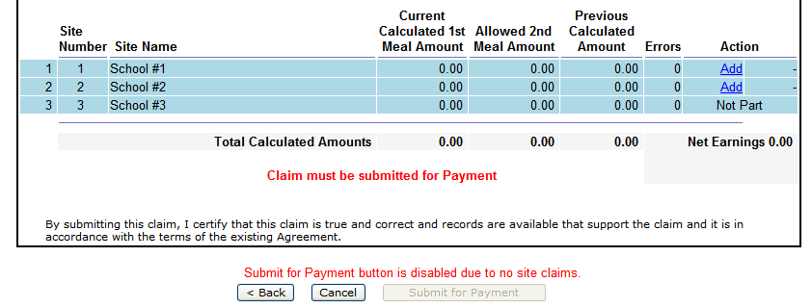
Site Level Claim Menu screen

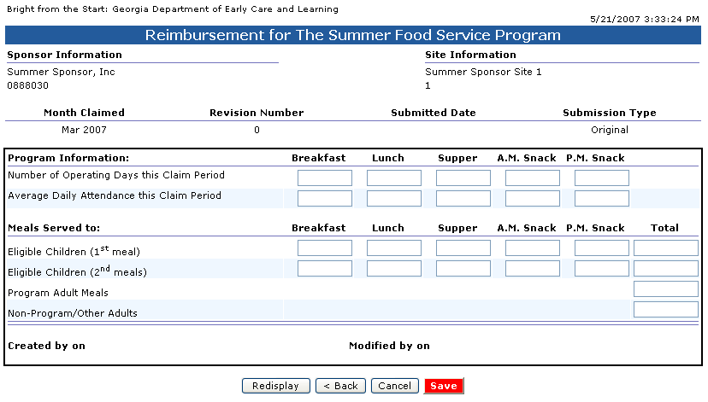
Site Claim screen

Enter the number of operating days, Average Daily Attendance and Eligible Children 1st meals for each meal type claimed. Enter Eligible Children 2nd meals for each meal type claimed, Program Adult Meals, Non-Program/Other Adults. Click Save.

If errors exist make corrections and click Save. You may save the page by clicking on Continue with Errors/Warnings> and return to the site claim later to make corrections.

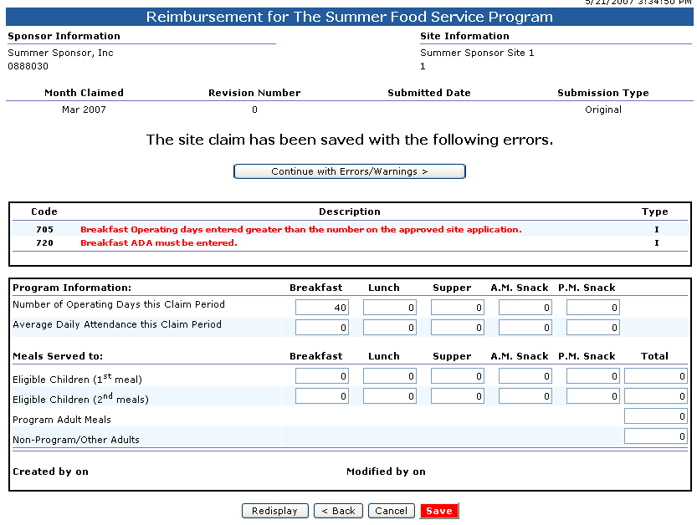
Site Claim screen with errors

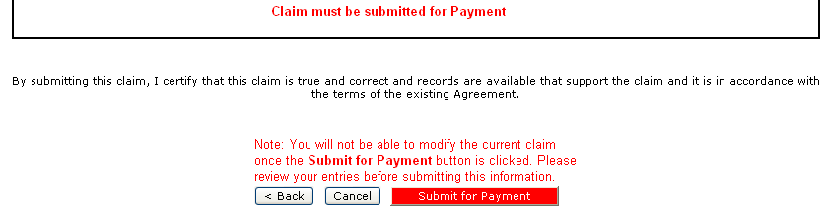
Site Level Claim Menu screen – Confirmation screen

Click Submit for Payment. Remember to review the claim before doing this action. The claim cannot be modified after the information has been submitted for payment.

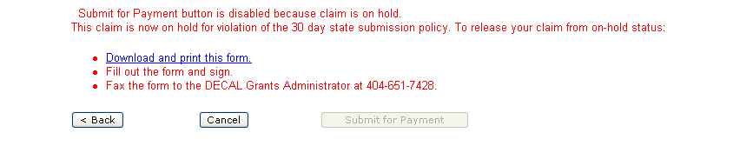
Site Level Claim Menu – view only screen

The claim becomes View Only after it is submitted for payment.
- Please click the blue hyperlink to download and print the claim.
- Fill out the form and sign.
- Fax the form to the DECAL Grants Administrator at 404-651-7428.

Site Level Claim – Upload procedure
After clicking on a claim month the following screen is displayed.

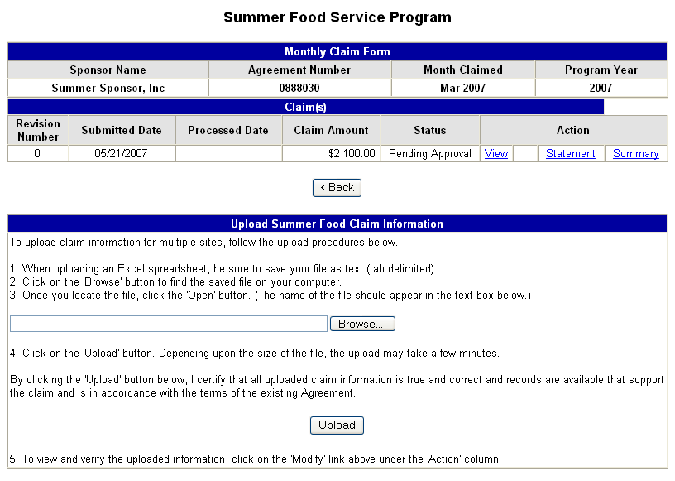
Month Summary screen

Claims may be entered manually using the Add or Modify links at the top right of the screen or may be uploaded as a file using the Upload Summer Food Claim Information section at the bottom of the screen.

The manual entry method is explained in the previous section.

Claim Upload
This section is intended to provide information used to upload site claim information. The process consists of two steps.

- Generate the File
- Upload the File

These steps are explained in the following sections.

Generate the file

Generating the file for the site claim is done using the tracking file where the meal, attendance or other information is stored. This file may contain most or only part of the information required on the site claim. The file must be set up using the required format so the information can be transferred to the center claim.

Specific information regarding the file layout can be obtained from DECAL. DECAL has an Excel file, which can be used to enter information for the claim. This file can then be uploaded into the system.

Once the SFSP file has been obtained from DECAL, save the file to a location on your computer or network where it can easily be located. The Save process contains the following steps.

- Click on File on the Excel menu.
- Click on Save As…
- Select a ‘Save in:’ folder, using the dropdown arrow.
- Select or ‘Enter a ‘File Name:’ using the dropdown arrow or by typing the name.
- Click on the dropdown arrow for ‘Save as type:’
- Select ‘Text (Tab delimited)(*.txt)’ (note the file must be saved with .txt as the extension)
- Click Save.

The file is now saved in a format, which can be uploaded.

Upload the file
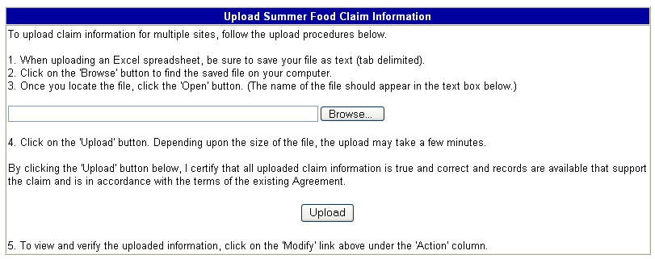
Month Summary Screen

Click on the Browse button to locate the file created in the previous section. Click on Open and then Upload to upload the file. After the file is uploaded the site level claims can be viewed using the manual access method explained in the previous section.

Reimbursement Statement
The Reimbursement Statement shows how the reimbursement is calculated. The Reimbursement Statement displays the information from the Claim and applies rates to the meals in order to calculate the reimbursement amount.

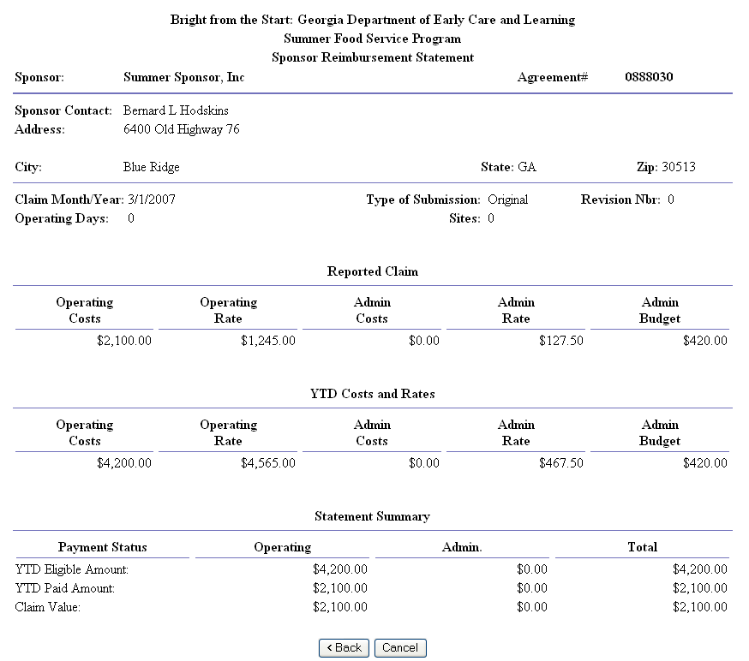 SFSP Reimbursement Claim Summary screen

The Reimbursement Statement also shows the Earnings or amount paid for the claim.

Notes

