Promoting Social Emotional Development Through Books

SEEDS for Story Time

Saturday
By Oge Mora

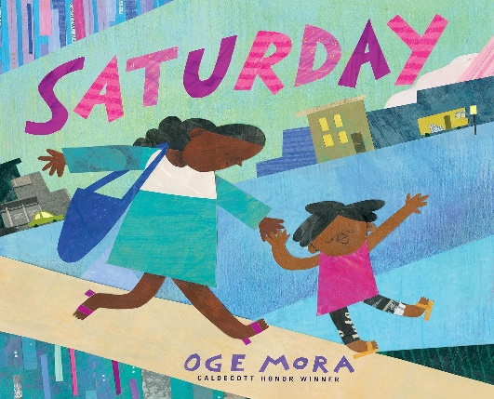
What happens when a mother and child’s favorite day goes all wrong. “Saturday was the day they cherished.” This must-read book is beautifully illustrated with collages created from patterned paper, clippings, paint, and markers. In the story Saturday, mother and child demonstrate how they cope with the unexpected. At each mishap, “they paused, closed their eyes, and whew! let out a deep breath.” Learning to accept disappointment is only one of the many lessons in this delightful story. (Ages 4-8)

CLL3.3d | .  Create Action Transition cards for the children to use when transitioning from one activity to another. These Action transition cards include the activities the children chose as the special events shared with friends and family, i.e., birthday parade, holding a kite or balloons, skipping to the park, favorite dance.
CLL3.3b | After reading the story Saturday, play a game of Feelings Charades. Review with the children the emotions expressed in the story. Next, choose a child to act out one of the feelings and encourage the other children to guess how the child’s feeling. The teacher can support the child acting out the feeling  with a whisper suggestion or use a visual facial expression card.
CLL2.3b | As you introduce the book and title, also introduce the word cherished, and define it. Talk with the children about days that are very special to them such as holidays, birthdays. You could chart the different types of cherished moments. Children could share how they would feel if they couldn’t celebrate their favorite day.
SEEDS for Story Time (cont.)

Introducing this book to young children:
R
epeated reading of the same book provides opportunities for preschoolers to develop a sense of competence and confidence. Children learn to point at and label pictures, turn pages, discuss the story, and make predictions of what will happen next, while learning new words and relating the story to their own experiences. Read Saturday for several days in a row and use some of the ideas, activities, and teaching opportunities listed below to enhance social and emotional skills.

GELDS Activity Spotlight

Blocks | Basket Full of Feelings: Provide plastic eggs and squares of paper with a different emotion on each one. Place a square inside each egg. Ask the child to scatter eggs in center then choose one egg to “crack” open. With your help read emotion on the square or use a picture. The children can talk about the emotions with you or another child. SED3.3b
Sensory  Table | Noodle Creations: Provide a variety of noodles, play dough, and pipe cleaners. Have the children create 3-D sculptures that illustrate a special event like a party, family festival. Ask children to describe the event that inspired their sculpture PDM1.3a
Small Group | Mad Jar: Create a “mad jar.” When a child gets upset, he/she goes to the mad jar, opens the lid and shouts into the jar. After shouting, the child puts lid back on jar. Consider decorating the jar with words and facial expressions. SED3.3b
Families share many special events that sometimes leave them feeling frustrated, disappointed, or a range of emotions. This activity helps a family identify and share with each other how they are feeling throughout the day. The Feeling Meter can be made from card stock or poster board divided by into six sections. Label each section with a different emotion such as happy, sad, frustrated, disappointed, worried. Attach an arrow with a brass fastener. Have the child and parent turn it to indicate how they are feeling throughout the day. In addition to the Feeling Meter, a family can use photo cards to identify feelings. SED2.3b

Focus on Family

WASHING
MACHINE

