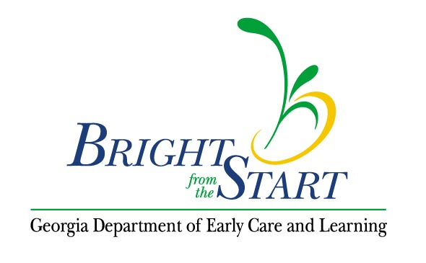
Georgia’s Pre-K Program
Follow-Up Conference Form

Student Name:
Program Name:
Date: / /
Review of Progress:

If acceptable progress was made, list the next steps (maintain implemented strategies, slowly reduce accommodations, focus on a new skill or behavior, etc.)

If acceptable progress was not made, list outside resources that will be contacted by the Pre-K program or the family (Pre-K consultant, resource and referral agency inclusion coordinator, school system, private providers in the community, etc.).

Continue with the original skill and or behavior or select a new one when appropriate. List the strategies and documentation method.
Skill or Behavior | Strategy | Type of Documentation

Conference Members (Signatures)

Relationship to child (mother, teacher, etc.)

Date of follow-up conference: / /
Follow-up Conference #:

