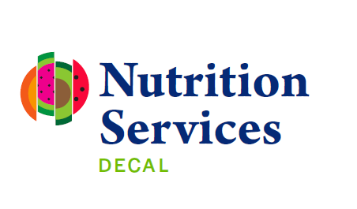

Bright from the Start: Georgia Department of Early Care and Learning
Excess Funds Use Request Form
Sponsor Name: | Agreement: | Fiscal Year:
Excess Happy Helpings  Prior Year Funds: $  Excess CACFP  Prior Year Funds: $  Excess DCH  Prior Year Funds: $ | Operate Other Child Nutrition Programs  Yes No  If yes, check CN Programs:  CACFP NSLP SBP HH  Amount used towards other CN Program Costs: $
Any amount of reimbursement or funds that remains at the close of the Food Program and which exceeds a sponsor’s expenditures, must be retained, and expended solely for food service operations or improvements.
Allowable Uses of Excess Funds
There are a variety of allowable uses for program excess funds. These include, but are not limited to:
- Necessary and reasonable improvement to kitchen facilities or equipment as it directly relates to preparing creditable meals (This requires specific prior written approval.).
- Expanding the variety of creditable meals.
- Increasing the amount and variety of whole grains, fresh fruits, and vegetables.
- Enhancing the service of vegetables by serving more legumes and dark leafy green vegetables.
- Enhancing monitoring or oversight of the food service; and
- Enhancing specialized meal services for children with food allergies.

Instructions: Using the table below, list all expenditures for the current fiscal year that will be paid with prior year excess HH/CACFP/DCH reimbursement funds and attach supporting documentation, such as time and attendance records, receipts, invoices, contracts, labor records, etc., supporting each expenditure. Per federal regulations, funds can only be used to pay for allowable Program costs. Sufficient documentation must be available to support the costs, maintained on file and made available for review upon request by USDA, Bright from the Start, and any of its agents. Upload documentation to Atlas in the appropriate program year and submit request via email to nutritionbudget@decal.ga.gov.
List the Cost Items Below (attach supporting documentation) | Amount of Cost | Anticipated Date of Purchase | Type of Cost | State Agency Review/Approval
Operating
Administrative
Operating
Administrative
Operating
Administrative
Operating
Administrative
Operating
Administrative
Operating
Administrative
Operating
Administrative
Operating
Administrative
I certify that the information provided on this form is true and correct and that costs will be incurred for the sole purpose of enhancing food service operations. I further agree to include the amount of excess funds and all costs incurred and paid with excess funds in the budget for the upcoming fiscal year.
_________________________________________ ________________
Signature of Officer or Delegated Principal Date
________________________________________
Position/Title
Staff Use Only:
CACFP costs approved:
SFSP costs approved:
Total Costs approved:

Notes:_______________________________________________________________
____________________________________________________________________
____________________________________________________________________

_________________________________________ ________________
Signature of State Agency Approval Date

