Literacy | Mindful Monday,  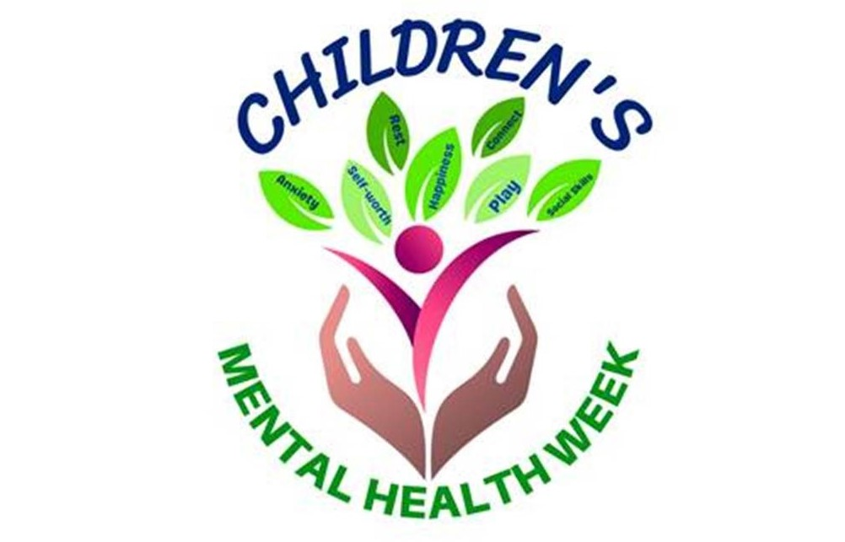  May 3rd | Talk It Out Tuesday,  May 4th | Wellness Wednesday,  May 5th | Thoughtful Thursday,  May 6th | Feelings Friday,  May 7th
 | First, learn the proper technique to Belly Breathe, then enjoy listening to the story Belly Breathe recall the way we put our hands on our belly to breathe out the bad. | It’s Okay to Be Different  Listen to this read aloud with your child. Have your child identify which characters in the book are like them. | Don’t Feed the Worry Bug  Engage in a discussion about how your child feels when they worry. What does a worry face look like? What did Wince do to get rid of the Worry Bug? | You Matter  Discuss the story as you read along. Has anyone ever said you were a pest? If you fall, has anyone ever been too busy t0 help you? | The Boy with Big, Big Feelings  Why did the boy try to stuff all his feelings deep down? What changed…why did he feel he no longer had to hide his emotions?
Phonological  Awareness | Mother Goose Monday  Have your child choose their favorite nursery rhyme to see and say together or introduce him/her to your favorite! | I Say, You Say  I say /H/…you say /elp/  /H/ – /elp/  /H/ – /elp/  What do we do for others?  We HELP our friends!  (try it again with other words) | Willaby Wallaby Wednesday  Help your child make up rhyming words for their name and the names of other family members. You can also try to rhyme some of the Mental Health vocabulary words like: Kind, Feelings, Sad, etc. | What’s that Sound?  Go outside with your child, get comfortable, be perfectly still, quiet, and close your eyes. See who can spot sounds, using only his/her ears. | Sentence segmenting  Say simple sentences, like:  I can handle it.  Using small objects like pebbles or pennies, count the words by placing one penny in a line for each word.
Music & Movement | Don’t Worry…Be Happy  Sad, Bad, Terrible Day  Belly Breathe song | Jungle Yoga Safari Adventure  This Is How I Do It  Dr. Knickerbocker | Mood Walk  Kindness  Make New Friends | Have A Good Morning  Kindness Is A Muscle  Friends Song | Counting by 5’s – march along  Run the Red Carpet  Celebrate
Math & Science | List of Letters  Think of words with your child that describes them. Help them count the number of letters in each descriptive word. Find which word has the most/least letters. | Pyramid Builders  Using plastic cups, challenge your child to build a pyramid as tall as possible. How tall will make it fall? | Water Wednesday  Fill a bucket with water. Then fill measuring cups or spoons with water. Discuss which cup or spoon holds the most water? Least? I wonder if the cups or spoons sink or float? | Cloud Shapes  Go outside with paper/writing utensil, lay down, and observe the clouds. What shapes do you see in the sky? Create the shapes on your paper. Describe the different clouds. | Friday Find and Sort  Help your child find 5-10 small objects. Have them sort the objects by color, size, number of holes (buttons), number of legs (toy animals), or sort by other attributes.
Motor Skills | Move with Me Monday  After singing and following along, see how long you and your child can balance on one leg. Change legs, try a different pose. | Tuesday Tweezer Trek  Walk with your child around your yard and see what they can collect using tweezers. Don’t forget a tin to put it all in! | To Make Me Feel OK  Sing about things you can do to feel ok…blow bubbles, play with something you like, think of someone you love, breathe slow, it will all be ok. | Playdoh Name Party!  Have your child make the letters of his/her name by rolling and shaping each letter. | Don’t Give Up  Ramp up these gross motor skills: play catch, row a boat, go skating, or practice balancing. Try and try some more…don’t give up!
Social  Emotional | Calming down with Cali  Cali knows just what to do when it comes to calming down. Have your child recall what to do if…? | I Can Handle It  Discuss how emotions make us feel, and ways your child can handle anything! New mantra to say: “I can handle it!” | Shake It Off  Shake off those yucky feelings so we can move on with our day. Our body can help by shaking it off. | Read The Color Monster Talk about what makes you feel the many different emotions (colors) that were mentioned in the book. | Big Feelings  It is helpful for children to learn that others struggle with big feelings, too. Play the  Feeling Faces Game

