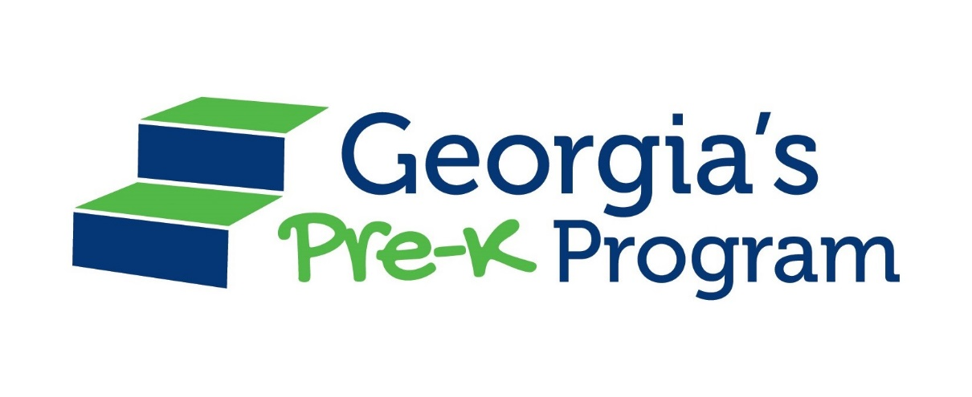

Georgia’s Pre-K Program
Book List

The Georgia’s Pre-K Program Book List will be available soon!

