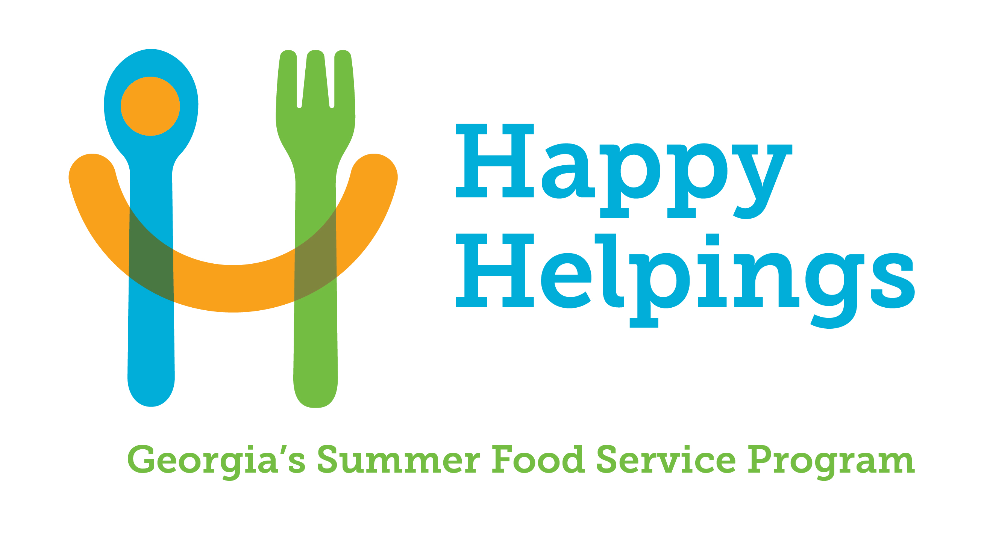
HAPPY HELPINGS: GEORGIA’S SUMMER FOOD SERVICE PROGRAM

ENROLLEE RELEASE CERTIFICATION

Enrolled Sites, Camps, and Conditional Non-Congregate Sites

Original Update Date Updated

This certifies that potential enrollees/enrollees received information in the sample below.
Type of communication used to disseminate information (e.g., email, flyer, social media): | Date Disseminated
Sample Release Information
The is participating in Happy Helpings: Georgia’s Summer Food Service Program. Meals will be provided to all eligible children free of charge. (To be eligible to receive free meals at a residential camp, children must meet the income guidelines below for reduced price meals in the National School Lunch Program.) Children who are part of households that receive foods stamps, or benefits under the Food Distribution Program on Indian Reservations (FDPIR), or Temporary Assistance to Needy Families (TANF) are automatically eligible to receive free meals.

Acceptance and participation requirements for the program and all activities are the same for all regardless of race, color, national origin, sex (including gender identity and sexual orientation), disability, age or reprisal or retaliation for prior civil rights activity. There will be no discrimination in the course of the meal service. Attached is a list of sites with the start and end times of meal service for each site.

(Effective from July 1, 2024, to June 30, 2025) *
48 CONTIGUOUS STATES, DISTRICT OF COLUMBIA, GUAM, AND TERRITORIES
HOUSEHOLD  SIZE | REDUCED PRICE MEALS - 185% |  |  | FREE MEALS – 130%
HOUSEHOLD  SIZE | ANNUAL | MONTH | WEEK | ANNUAL | MONTH | WEEK
1 | 27,861 | 2,322 | 536 | 19,578 | 1,632 | 377
2 | 37,814 | 3,152 | 728 | 26,572 | 2,215 | 511
3 | 47,767 | 3,981 | 919 | 33,566 | 2,798 | 646
4 | 57,720 | 4,810 | 1,110 | 40,560 | 3,380 | 780
5 | 67,673 | 5,640 | 1,302 | 47,554 | 3,963 | 915
6 | 77,626 | 6,469 | 1,493 | 54,548 | 4,546 | 1,049
7 | 87,579 | 7,299 | 1,685 | 61.542 | 5,129 | 1,184
8 | 97,532 | 8,128 | 1,876 | 68,536 | 5,712 | 1,318
For Each Additional Person Add | + 9,953 | + 830 | + 192 | +6,994 | + 583 | + 135

In accordance with federal civil rights law and U.S. Department of Agriculture (USDA) civil rights regulations and policies, this institution is prohibited from discriminating on the basis of race, color, national origin, sex (including gender identity and sexual orientation), disability, age, or reprisal or retaliation for prior civil rights activity.
Program information may be made available in languages other than English. Persons with disabilities who require alternative means of communication to obtain program information (e.g., Braille, large print, audiotape, American Sign Language), should contact the responsible state or local agency that administers the program or USDA’s TARGET Center at (202) 720-2600 (voice and TTY) or contact USDA through the Federal Relay Service at (800) 877-8339.
To file a program discrimination complaint, a Complainant should complete a Form AD-3027, USDA Program Discrimination Complaint Form which can be obtained online at: https://www.usda.gov/sites/default/files/documents/ad-3027.pdf, from any USDA office, by calling (866) 632-9992, or by writing a letter addressed to USDA. The letter must contain the complainant’s name, address, telephone number, and a written description of the alleged discriminatory action in sufficient detail to inform the Assistant Secretary for Civil Rights (ASCR) about the nature and date of an alleged civil rights violation. The completed AD-3027 form or letter must be submitted to USDA by:
- mail:
U.S. Department of Agriculture
Office of the Assistant Secretary for Civil Rights
1400 Independence Avenue, SW
Washington, D.C. 20250-9410; or
- fax:
(833) 256-1665 or (202) 690-7442; or
- email:
program.intake@usda.gov

This institution is an equal opportunity provider.

I certify that the Enrollee Release information sent to potential enrollees/enrollees included all the Sample Release Information including a complete listing of all current sites, mealtimes and the non-discrimination statement. In addition, I certify that all children are served the same meals and that there is no discrimination in the course of the food service and the meals served are free at all sites (with the exception of camps and conditional non-congregate meal sites).

Signature of Sponsor Representative Date

