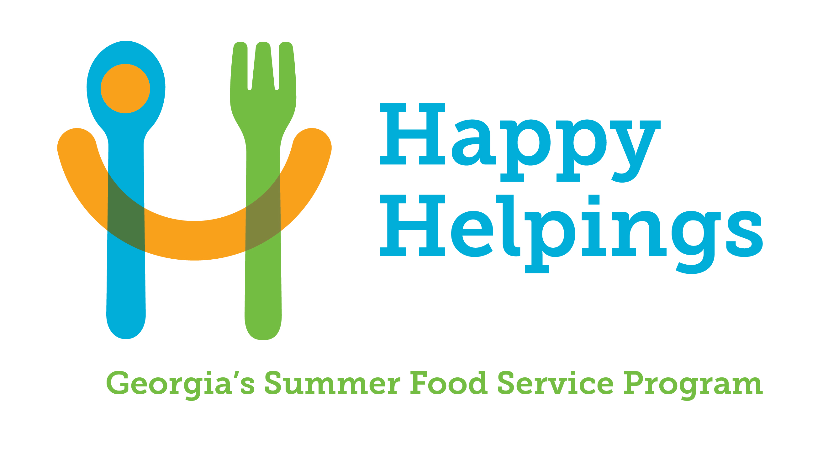

HAPPY HELPINGS: GEORGIA’S SUMMER FOOD SERVICE PROGRAM

PUBLIC RELEASE CERTIFICATION
Open Migrant and Open Sites

Original Update Date of Revision
Sponsors are required to send public releases to the media located in the area where the site(s) draws its attendance. Include a list of all approved sites with their location, dates of operation, serving times and the non-discrimination statement. The Press Release should be on the organization letterhead, a sample is provided below. Keep a copy of the public releases sent to the media.
This certifies that the following media outlets received a Press Release containing the information in the Sample below.
Name of Media Outlet | Date of Scheduled Release |  | Name of Media Outlet | Date of Scheduled Release

Press Release Sample
The (Name of Sponsor) is participating in the Summer Food Service Program. Meals will be provided to all children without charge. Acceptance and participation requirements for the program and all activities are the same for all regardless of race, color, national origin, sex, age or disability, and there will be no discrimination in the course of the meal service. Meals will be provided at all sites listed on the attached form showing the specified start and end times for meals (Include Attachment C-3).

In accordance with federal civil rights law and U.S. Department of Agriculture (USDA) civil rights regulations and policies, this institution is prohibited from discriminating on the basis of race, color, national origin, sex (including gender identity and sexual orientation), disability, age, or reprisal or retaliation for prior civil rights activity.
Program information may be made available in languages other than English. Persons with disabilities who require alternative means of communication to obtain program information (e.g., Braille, large print, audiotape, American Sign Language), should contact the responsible state or local agency that administers the program or USDA’s TARGET Center at (202) 720-2600 (voice and TTY) or contact USDA through the Federal Relay Service at (800) 877-8339.
To file a program discrimination complaint, a Complainant should complete a Form AD-3027, USDA Program Discrimination Complaint Form which can be obtained online at: https://www.usda.gov/sites/default/files/documents/USDA-OASCR%20P-Complaint-Form-0508-0002-508-11-28-17Fax2Mail.pdf, from any USDA office, by calling (866) 632-9992, or by writing a letter addressed to USDA. The letter must contain the complainant’s name, address, telephone number, and a written description of the alleged discriminatory action in sufficient detail to inform the Assistant Secretary for Civil Rights (ASCR) about the nature and date of an alleged civil rights violation. The completed AD-3027 form or letter must be submitted to USDA by:
- mail:
U.S. Department of Agriculture
Office of the Assistant Secretary for Civil Rights
1400 Independence Avenue, SW
Washington, D.C. 20250-9410; or

- fax:
(833) 256-1665 or (202) 690-7442; or
- email:
program.intake@usda.gov

This institution is an equal opportunity provider.

I certify that the Public Release sent to the above media outlets included all the information required for the Public Release; including a complete listing of all current sites and meal times and the non-discrimination statement. In addition, I certify that all children are served the same meals and that there is no discrimination in the course of the food service and the meals served are free at all sites.

Signature of Sponsor Representative Date

