Dear Parent/Guardian,

[Insert Center or Sponsoring Organization Letterhead]
Indicate name of sponsor serves nutritious meals to children enrolled in their programming without an additional charge to you. This is possible because federal reimbursement is received for meals served in accordance with regulations governing the USDA Summer Food Service Program (SFSP). To document eligibility for these funds, statements of household size and income must be obtained from parents or guardians of children participating in the SFSP. Meals are available to children 18 years of age and under and to persons over age 18 who are determined by a state or local public educational agency to be mentally or physically disabled. The information you provide will be used only to document that meals may be claimed for Summer Food Service Program assistance and will be kept confidential. If your income is higher than the amount indicated in the chart below for your household size, you do not need to complete the attached Household Application for the Summer Food Service Program.

Please complete and return the enclosed Income Eligibility Statement, Att. 10 if:

  - A member of your household is receiving benefits from the Supplemental Nutrition Assistance Program (SNAP), Temporary Assistance for Needy Families (TANF), or the Food Distribution Program on Indian Reservations (FDPIR).
  - You have one or more foster children in your household (child under the legal responsibility of a foster care agency or court).
  - The children in your household meet the definition of homeless, runaway, or migrant.
  - The children in your household participate in a Head Start program.
  - Your household income falls at or below the income guidelines on the chart below.

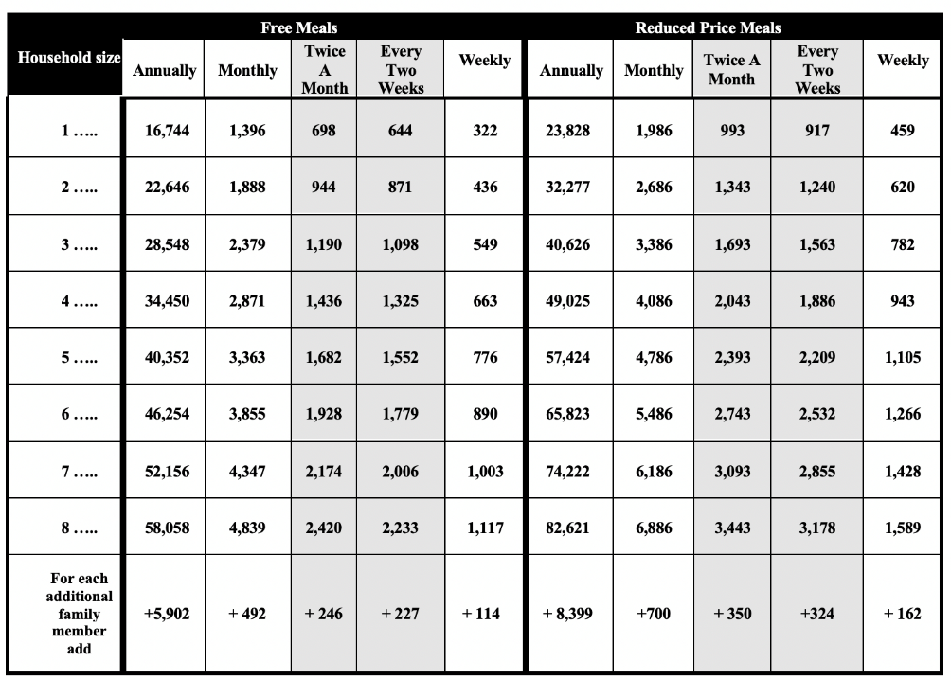

If you have questions or need help, call [phone number].

Sincerely,

[signature]

